Tolong bikinin ini

AES (Key length 16 bytes, No. of round = 10)

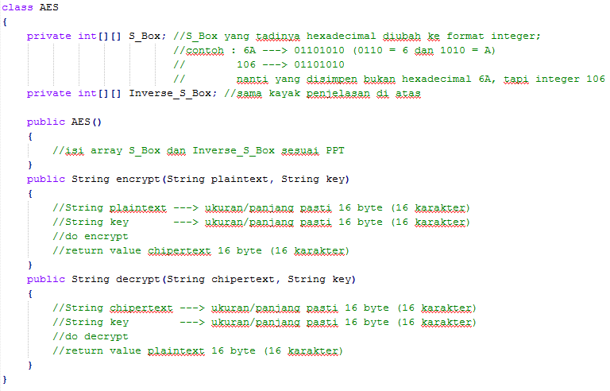

CFB (Chipper Feedback) (class AES harus udah selesai)

